**TOY STORE ERD**

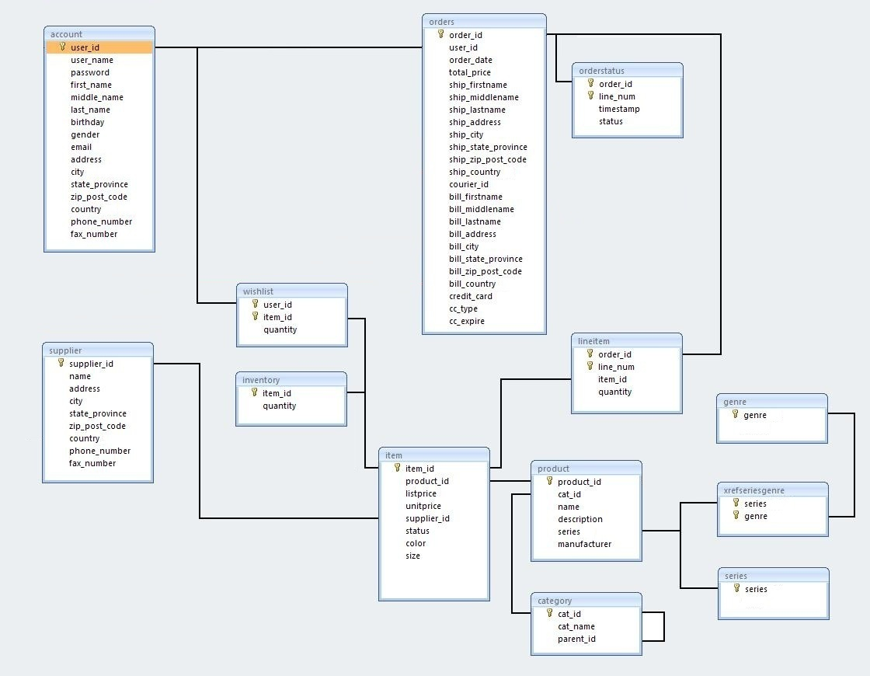

**ENTITY** **& ATTRIBUTE METADATA**

**account**

Anyone who wants to buy something from the online toy store must have an account.

|  |  |  |
| --- | --- | --- |
|  | *Data Type* | *Other Constraints* |
| •user_id: The account holder's unique identifier. | Autoincrement integer | Primary key |
| •user_name: The account holder's user name. Must be unique. | Variable length string, max 32 | Unique, Not Null |
| •password: The account holder's password. | Variable length string, max 32 | Not Null |
| •first_name: The account holder's first name. | Variable length string, max 32 | Not Null |
| •middle_name: The account holder's middle name. | Variable length string, max 32 | Not Null |
| •last_name: The account holder's last name. | Variable length string, max 32 | Not Null |
| •birthday: The account holder's birthday. | Date | Not Null |
| •gender: The account holder's gender | Fixed length 1 char | Allow M or F, Default M |
| •email: The account holder's e-mail. | Variable length string, max 64 | Not Null |
| •address: The account holder's street address. | Variable length string, max 64 | Not Null |
| •city: The account holder's city. | Variable length string, max 32 | Not Null |
| •state_province: The account holder's state or province. | Variable length string, max 32 | Not Null |
| •zip_post_code: The account holder's zip or postal code. | Variable length string, max 10 | Not Null |
| •country: The account holder's country identifier. | Fixed length 3 chars | Not Null |
| •phone_number: The account holder's telephone number. | Variable length string, max 32 | Not Null |
| •fax_number: The account holder's fax number. | Variable length string, max 32 | Not Null |

**category**

The toy store sells products that can be divided into several categories and subcategories. For example, the Wall Art category may be further divided into the subcategories Posters and Wall Scrolls.

|  |  |  |
| --- | --- | --- |
| •cat_id: A unique identifier representing an anime product category or subcategory. | Int (small range of Values)  Auto Increment | Primary Key |
| •cat_name: The name of an anime product category or subcategory (for example, Music, Posters, etc.). | Variable length string, max 64 | Not Null  Unique |
| •parent_id: A reference to the parent category identifier for this product category. NULL for top-level categories, not NULL for subcategories. | Int (Small range of values) | Unary foreign key |

**genre**

Every product may be associated with zero or more genres, such as Fantasy, Magic, and Science Fiction.

|  |  |  |
| --- | --- | --- |
| •genre: representing an anime genre (for example Horror). | Variable length string, max 32 | Unique  Primary key |

**item**

Every product can be subdivided into one or more items. For example, a Chococat t-shirt may come in a variety of different colours such as White (for boys) and Pink (for girls). It's the same product (a Chococat t-shirt made by a certain manufacturer), but there are two items available for this product, a white t-shirt and a pink t-shirt. Also note that perhaps the t-shirt might come in different sizes, such as small, medium, large, and extra large.

|  |  |  |
| --- | --- | --- |
| •item_id: A unique identifier representing this item. | Integer  auto increment | Primary Key, Not Null |
| •product_id: A reference to the product that this item is derived from. | Small range of values integer | Foreign key to product.product_id |
| •listprice: The MSRP (manufacturer's Suggested Retail Price). | Decimal to 2 digits | Not Null |
| •unitprice: The price of this product (that we are selling it for). | Decimal to 2 digits | Not Null |
| •supplier_id: A reference to the supplier that provides our toy store with this product. | Integer | Not Null  Foreign key to supplier.supplier_id |
| •status: The status of the item. | Fixed length string | Allowable values: May be one of the following: A (for Available), O (for Out of Stock/Out of Print), B (for On Back Order), P (for Pre-Order) and R (for Reserved). |
| •colour: The colour of the item, if applicable | Variable length string to max 16 chars | Default NULL for no colour option, otherwise the colour option of the item |
| •size: The size of the item, if applicable | Variable length string to max 16 chars | Default NULL for no size option, otherwise the size option of the item |

**inventory**

The inventory table tracks the quantity of each item our toy store currently has in stock.

|  |  |  |
| --- | --- | --- |
| •item_id: A reference to an item that we sell. | Integer | Primary Key  Foreign key to item.item_id |
| •quantity: The quantity of this item that our toy store currently has in stock. | Positive Integer | Not Null |

**lineitem**

A single order may have one or more items associated with it.

|  |  |  |
| --- | --- | --- |
| •order_id: A reference to an order. | Integer | Not null  Foreign key to order.order_id  Component of composite Primary key |
| •line_num: The ith product item that you are ordering. | Positive small integer | Not Null  Component of composite Primary key |
| •item_id: A reference to the item that you are ordering. | Integer | Not null  Foreign key to item.item_id |
| •quantity: The quantity of this product item that you are ordering. | Positive Small Integer | Not Null, Default 1 |

**orders**

The orders table stores all completed orders submitted by account holders. Incomplete or partial order transactions are not stored in the orders table.

|  |  |  |
| --- | --- | --- |
| •order_id: A unique identifier representing a completed order transaction. | Integer  Auto increment | Primary Key  Not Null |
| •user_id: A reference to the account holder's account information. | Integer | Not Null  Foreign key to account.user_id |
| •order_date: The date the order was placed. | Date | Not Null  Default system date |
| •total_price: The total price of the order (the sum of the prices of all line orders). | Real number to two decimal places | Not Null |
| •ship_firstname: The first name of the person to ship to (if NULL, we use the first name of the account holder). | Variable length string to 32 characters | Nulls allowed |
| •ship_middlename: The middle name of the person to ship to (if NULL, we use the middle name of the account holder). | Variable length string to 32 characters | Nulls allowed  Default NULL |
| •ship_lastname: The last name of the person to ship to (if NULL, we use the last name of the account holder). | Variable length string to 32 characters | Nulls allowed |
| •ship_address: The street address of the person to ship to (if NULL, we use the street address of the account holder). | Variable length string to 128 characters | Nulls allowed |
| •ship_city: The city location of the person to ship to (if NULL, we use the city location of the account holder). | Variable length string to 32 characters | Nulls allowed |
| •ship_state_province: The state location of the person to ship to (if NULL, we use the state location of the account holder). | Variable length string to 32 characters | Nulls allowed |
| •ship_zip_post_code: The zip or postal code of the person to ship to (if NULL, we use the zip or postal code of the account holder). | Variable length string to 32 characters | Nulls allowed |
| •ship_country: The country of the person to ship to (if NULL, we use the country of the account holder). | Fixed length 3 digits to represent country | Nulls allowed |
| •courier_id: A reference to the shipping courier the account holder has selected to use for shipping. | Variable length string to 16 characters | Not null |
| •bill_firstname: The first name of the person to bill. Should be equal to the first name on the credit card. | Variable length string to 32 characters | Nulls allowed |
| •bill_middlename: The middle name of the person to bill. Should be equal to the middle name on the credit card. | Variable length string to 32 characters | Nulls allowed |
| •bill_lastname: The last name of the person to bill. Should be equal to the last name on the credit card. | Variable length string to 32 characters | Nulls allowed |
| •bill_address: The street address of the person to bill. | Variable length string to 32 characters | Nulls allowed |
| •bill_city: The city location of the person to bill. | Variable length string to 32 characters | Nulls allowed |
| •bill_state_province: The state location of the person to bill. | Variable length string to 32 characters | Nulls allowed |
| •bill_zip_post_code: The zip or postal code of the person to bill. | Variable length string to 32 characters | Nulls allowed |
| •bill_country: The country of the person to bill. | Variable length string to 32 characters | Nulls allowed |
| •credit_card: The account holder's credit card number. | Fixed length string 16 chars | Not Null |
| •cc_type: The account holder's credit card type | Variable length to max 10 | Not Null  Check constraint (Visa, MasterCard, AMEX). |
| •cc_expire: The account holder's credit card expiration date. | DATE | Not Null |

**orderstatus**

Once an order is created, it has to be processed by the toy store and all line items must be packaged and arranged for shipping. In fact, all orders and line items may go through several departments such as packaging and shipping. During this processing, each line item may be in one of several states, such as I (in initial processing), P (in packaging), S (in shipping), and T (shipped and in transit).

|  |  |  |
| --- | --- | --- |
| •order_id: A reference to an order. | Integer | Not Null  Component part of primary key  Foreign key references order.order_id |
| •line_num: The line item number (the ith item in the order). | Integer | Not Null  Component part of primary key |
| •timestamp: The date the line item was received by the packaging or shipping departments. If in initial processing, the time stamp is the date the order was created. If shipped, the time stamp is the date the line item was shipped. | Timestamp /Date (to minutes) | Not Null  Default system date |
| •status : I (if in initial processing), P (if in packaging department), S (if in shipping department), and T (if shipped and in transit). | Fixed length char 1 | Allowable values I, P, S, T  Default I |

**product**

The product table contains general information about all of the products for sale.

|  |  |  |
| --- | --- | --- |
| •product_id: A unique identifier representing the product we are selling. | Small range of integers | Not Null  Primary key |
| •cat_id: A reference to the category that this product is associated with. | Very small range of integers | Foreign key references category.cat_id |
| •name: The name of the product we are selling. | Variable length string to max 128 chars | Not Null |
| •description: A description of the product we are selling, usually the manufacturer's description. | Variable length string to max 1028 chars | Not Null |
| •series: A reference to the anime series that this product is associated with. | Variable length string to max 128 chars | Not Null  Foreign Key references series.series |
| •manufacturer: The name of the manufacturer for this product. | Variable length string to max 128 chars | Not Null |

**series**

All products in our database are associated with an anime television series.

|  |  |  |
| --- | --- | --- |
| •series: A unique string representing an anime series (for example Hello Kitty). | Variable length string to max 128 chars | Not Null  Primary Key |

**supplier**

A supplier is a person or company that provides our toy store with toys. Rarely does a store deal directly with the toy manufacturer. Instead, a store usually deals with a supplier who is able to order toys in heavy bulk directly from the manufacturer.

|  |  |  |
| --- | --- | --- |
| •supplier_id: A unique identifier representing a supplier. | Integer  Auto increment | Not Null  Primary Key |
| •name: The business name of the supplier. | Variable length string to max 64 chars | Not Null |
| •address: The business address of the supplier. | Variable length string to max 128 chars | Not Null |
| •city: The city location of the supplier. | Variable length string to max 32 chars | Not Null |
| •state_province: The state location of the supplier. | Variable length string to max 32 chars | Not Null |
| •zip_post_code: The zip or postal code of the supplier. | Variable length string to max 32 chars | Not Null |
| •country: The country of the supplier. | Fixed length string of 3 chars | Not Null  Default ‘IRE’ |
| •phone_number: The phone number of the supplier. | Variable length string to max 32 chars | Not Null  Unique |
| •fax_number: The fax number of the supplier. | Variable length string to max 32 chars | Nulls Allowed |

**xrefseriesgenre**

Every anime series may be associated with multiple genres.

|  |  |  |
| --- | --- | --- |
| •series: A reference to a series. | Variable length string to max 128 chars | Not Null  Component part of composite primary key  Foreign key to series.series |
| •genre: A reference to a genre that is associated with this series. | Variable length string to max 32 chars | Not Null  Component part of composite primary key  Foreign key to genre.genre |